INTRODUCTION
This package includes the instructions, application form, and the PASE Instrument for completing a Partnerships Audit Standard Equivalency (PASE).

PURPOSE
The PASE process provides an alternative to conducting regular Certificate of Recognition (COR) audits for large employers with their own established corporate health and safety management audit systems and annual corporate auditing programs. The employer’s corporate audit system is compared to the requirements of the Partnerships Audit Standard by the Certifying Partner (Energy Safety Canada). Where sufficient equivalency can be established, employers may seek COR certification based on the audit findings from their own corporate audits. The corporate audits can be conducted either by Energy Safety Canada certified auditors or corporate auditors that are sufficiently qualified, and in certification years, are independent from the operations audited. The corporate audit results are transferred by a PASE auditor using a standard template, and if PASE scoring requirements are met, the employer is eligible for a COR. The PASE auditor can either be a Energy Safety Canada certified auditor or an approved corporate auditor. The PASE process can also be used for COR maintenance.

The following instructions are intended to be used as a guide for completing the PASE package. Parts One and Two of the package must be filled out and submitted to your Energy Safety Canada by June 30th.

INSTRUCTIONS
PART 1: PASE APPLICATION

PASE APPLICATION
The application (completed by the employer) and supporting documentation must be received by your Certifying Partner (Energy Safety Canada) no later than June 30th to use the PASE process for the current year.

- Respond to each question on the application and fill out applicable tables.
- Limit all descriptions of company activities and operations to those that are to be included in the PASE process.
- Explain any acronyms used in the application, gap analysis or other documents.
- Attach the following corporate health and safety audit system documents:
- Audit policy and procedures
- Audit scoring or rating guidelines
- Sampling policy and procedures
- Any other guidance documents

TABLE 1: PROPOSED AUDIT SCOPE SUMMARY
The proposed audit scope summary must be completed in order to fulfill Partnerships’ data requirements and to determine which corporate audits are required for PASE. Include the employer’s proposed audit start and end dates; identify which sites will be included in the scope (this must include the head office for Alberta operations); indicate the approximate number of employees and interviews to be conducted.
The audit scope summary is to be completed with the proposed sampling details. Each line represents a single fixed location. All fixed locations need to be included (both those within and outside the audit scope) and all fields are mandatory.

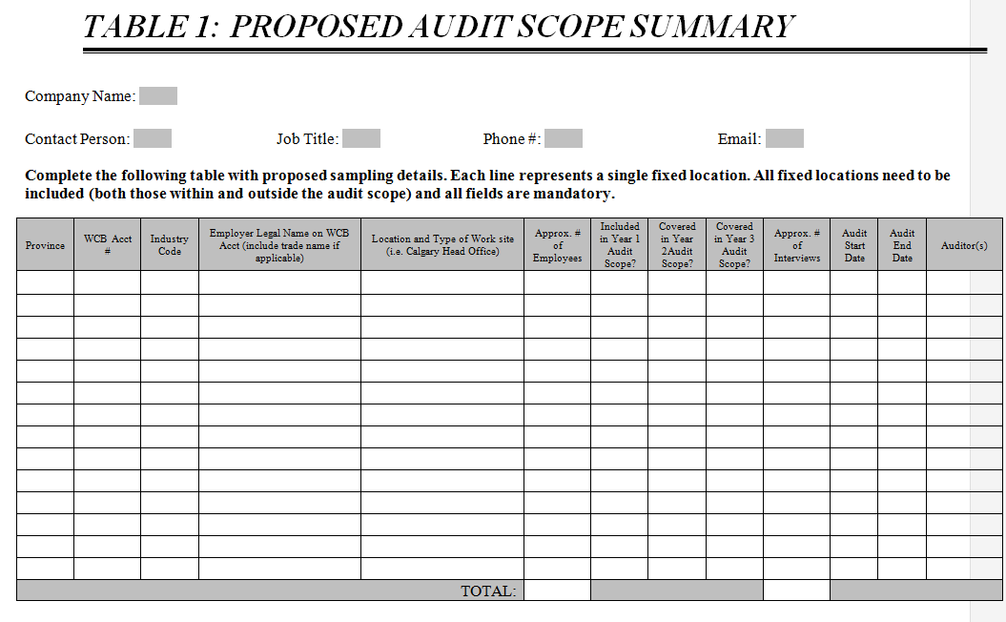

INFORMATION
PART 2: GAP ANALYSIS EQUIVALENCY REQIREMENTS

GAP ANALYSIS EQUIVALENCY REQUIREMENTS
The GAP assessment is completed by Energy Safety Canada. There is a fee associated with conducted the GAP Analysis. Click here to view the fees.

The Process
Based on a question by question comparison using the Partnerships Audit Standard, the employer’s health and safety audit must achieve a minimum of 85% equivalency overall, and no less than 60% equivalency for each element.
Energy Safety Canada uses the employer’s audit instrument and audit question guidelines that was submitted with their application to complete the gap analysis assessment.

If it does not meet the requirements of the standard, then the results are communicated with the employer with recommendations on how to meet the standard. If the requirements have been met, then the employer is eligible to move to the next step in the PASE process.

PART 1: PASE APPLICATION
The employer must submit this completed application to Energy Safety Canada by June 30th.

SECTION A – PASE USE QUESTIONNAIRE
Note: If questions 1 through 6 cannot be marked “Yes”, then the employer cannot proceed to the next section and is ineligible to use the PASE process.

- Does the employer have a minimum of 400 employees in Alberta?
☐ Yes
☐ No

- Has the employer developed their own corporate health and safety management system and audit process?
☐ Yes
☐ No
Please explain:

- Has the employer been conducting their own corporate health and safety audits for a minimum of three years?
☐ Yes
☐ No

- Does the employer’s audit cycle include an external audit at least every 3 years (An external audit requires the use of auditors unrelated to the audited work site)?
☐ Yes
☐ No
If “No,” please explain:

- Describe how the three required validation techniques are used inside the employer’s audit process.

- Explain how the employer’s audit system scores/rates their audit findings and how this system will be translated into PASE audit scores. *Include a copy of the employer audit standard as well as the audit protocol with this application.
Example:
Exceeds Standards 80% to 100%
Meets Standards 50% to 80%
Below Standards 0% to 50%

TABLE 1: PROPOSED AUDIT SCOPE SUMMARY

Company Name:

Contact Person: Job Title: Phone #: Email:

Complete the following table with proposed sampling details. Each line represents a single fixed location. All fixed locations need to be included (both those within and outside the audit scope) and all fields are mandatory.

Province | WCB Acct # | Industry Code | Employer Legal Name on WCB Acct (include trade name if applicable) | Location and Type of Work site (i.e. Calgary Head Office) | Approx. # of Employees | Included in Year 1 Audit Scope? | Covered in Year 2Audit Scope? | Covered in Year 3 Audit Scope? | Approx. # of Interviews | Audit Start Date | Audit End Date | Auditor(s)
TOTAL:

Depending on employer’s audit team, fill in either Section B (Employer’s Corporate Auditors) or Section C (Certifying Partner Auditors for Employer’s Corporate Audit)

SECTION B – USE OF EMPLOYER’S CORPORATE AUDITORS
Note: If the employer’s corporate auditor(s) has not been selected at the time of application, this application cannot receive final approval until that information is provided to the Certifying Partner.

Complete this section only if the employer will be using their own corporate auditors (i.e., company employees) to conduct the audits used for the PASE process. To demonstrate that corporate auditors are qualified and competent, the following questions must be answered.

Note: If the audit is conducted by an audit team, each member of the team must meet the criteria.

- Provide complete details of the employer’s corporate auditor training program.

- Describe how corporate auditors are certified or qualified by the employer to conduct audits. Please provide complete details.

- Describe the process used to maintain corporate auditor certification or qualification as auditors. Please provide complete details.

- Please provide the proposed list of auditors, their qualifications, recognized certifications, and their health and safety roles/responsibilities within the organization.

Note: If this application is being used for a maintenance audit, questions 5 to 9 may be left blank.
- Describe the organizational structure of the operation, indicating the reporting relationships of the various facilities and corporate health and safety auditing area.

- Do auditors report to the management of the audited facilities?
☐ Yes
☐ No
If “Yes,” please explain:
- Are auditors involved in the development/implementation of the health and safety system at the facilities to be included in the audit?
☐ Yes
☐ No
If “Yes,” please explain:

- Are auditors held accountable for the effectiveness of the health and safety system of the facilities to be included in the audit?
☐ Yes
☐ No
If “Yes,” please explain:

- Will the audit be conducted by an audit team?
☐ Yes
☐ No
If “Yes,” please explain:

- Describe how the employer selects corporate auditors used in “external” certification years.

Complete the following table for the employer’s proposed corporate auditors conducting the corporate audit for the PASE process:

TABLE 2: PROPOSED LIST OF CORPORATE AUDITORS
Name of Auditor | Current Auditor Qualification & Certifications | Brief Description of Auditing Experience | Brief Description of Role & Responsibilities for H&S within the Organization | Auditor’s Reporting Unit or Work Group

SECTION C - CERTIFYING PARTNER AUDITORS FOR EMPLOYER’S CORPORATE AUDIT

- Will the employer be using Certifying Partner certified auditor(s) to conduct the employer’s corporate audit(s)?
☐ Yes
☐ No
If “Yes,” please list the auditor(s) and provide the contact information of the auditor who will be conducting the employer’s corporate audit(s). Please complete the following table for the auditors that will be conducting the corporate audit for the PASE process:

Table 3: Auditor Information
Name of Auditor | Current Auditor Qualification & Certifications | Brief Description of Auditing Experience | Brief Description of Role & Responsibilities for H&S within the Organization | Auditor’s Reporting Unit or Work Group

SECTION D – PASE AUDITOR

CHOICE OF PASE AUDITOR(S)
Will the employer be using:
- Certifying Partner certified auditors (i.e. transferring and scoring the employer’s corporate audit results onto the PASE Audit Instrument and submitting the PASE Audit Report) to conduct the PASE audit?
OR
- Approved employer corporate auditors (i.e. transferring the employer’s corporate audit results onto the PASE Audit Instrument) to assist the PASE audit process?

Fill in the section that applies.
☐ A. Energy Safety Canada Certified Auditor(s) as PASE Auditor(s)

Please list the Certifying Partner certified auditor(s) and provide their contact information. Complete the following table for the auditors that will be conducting the corporate audit for the PASE process:

Table 4: Energy Safety Canada Certified Auditor
Name of Auditor | Current Auditor Qualification & Certifications | Brief Description of Auditing Experience | Brief Description of Role & Responsibilities for H&S within the Organization | Auditor’s Reporting Unit or Work Group

☐ B. Employer Corporate Auditor(s) as PASE Auditor(s)

Please list the Employer’s Corporate Auditor(s) who will be acting as PASE Auditor(s) and their contact information. Complete the following table for the corporate auditors that will be conducting the corporate audit for the PASE process:

Table 5: Employer’s Corporate Auditor(s) who will be acting as PASE Auditor
Name of Auditor | Current Auditor Qualification & Certifications | Brief Description of Auditing Experience | Brief Description of Role & Responsibilities for H&S within the Organization | Auditor’s Reporting Unit or Work Group

EMPLOYER REPRESENATITVE
We, the undersigned, hereby certify that, to the best of our knowledge, the information provided in this application is accurate and true.

Employer Representative:

Signature: Date:

PASE APPLICATION APPROVAL
This application meets the requirements outlined in SAC-PRO-014 COR PASE Program.

Certifying Partner:

Certifying Partner Representative:

Signature: Date:

PART 2: PASE GAP ANALYSIS EQUIVALENCY REQUIREMENT
To be completed by the Certifying Partner

**GAP ANALYSIS
To be completed by the Energy Safety Canada. The Energy Safety Canada will fill out Column 2 on the PASE Instrument.

Equivalency Requirements:
Based on a question by question comparison using the Partnerships Audit Standard, the employer’s health and safety audit must achieve a minimum of 85% equivalency overall, and no less than 60% equivalency for each element.
- Multiple employer audit questions may be required to achieve equivalency.
- The employer may add any missing audit question(s) to their own corporate audit.
  - Note: Any prior employer audits conducted without the additional questions may not be used for this PASE process.
- If the corporate audit does not have an equivalent audit question or does not completely cover the required question content or intent, the PASE auditor may conduct their own inquiries. The “Employer Notes” section of the template must indicate “PASE Auditor Verification” and a summary of inquiries and a list of any documents proposed for review must be recorded on the template.
- Where an equivalent audit question cannot be found or provided, these will be indicated as “no match.”

- Ensure the following corporate health and safety audit system documentation is attached to this application:

☐ Audit Instrument (required)
☐ Audit Question Guidelines (required)

**The PASE GAP Final Report Template will be release to the auditor after approval of the application and gap assessment process completed by Energy Safety Canada.

