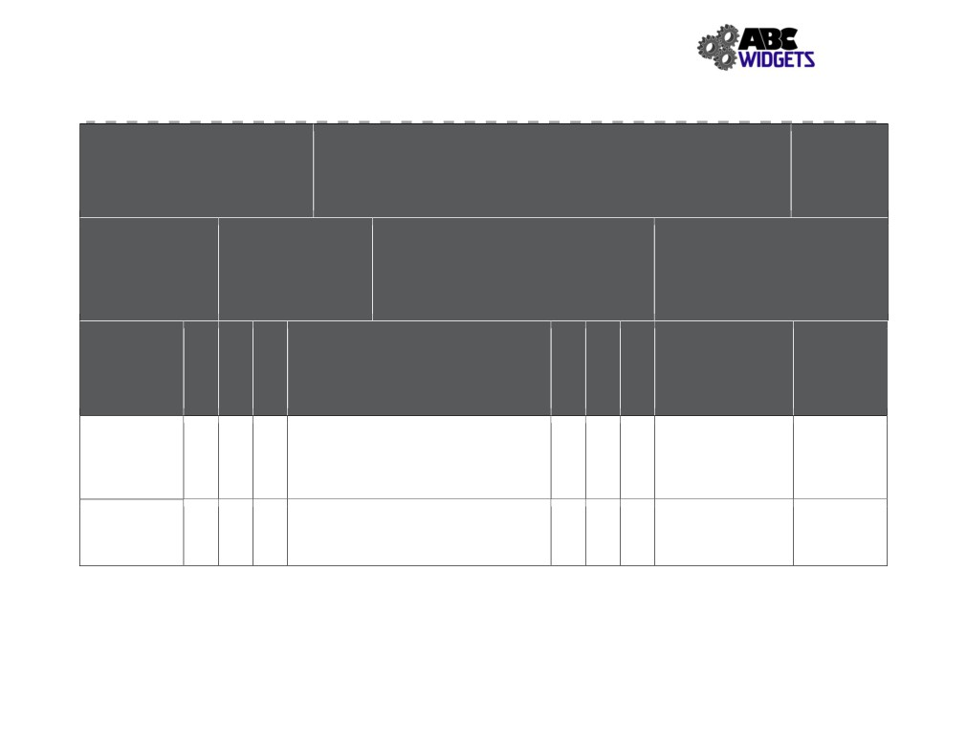

ABC Widget Oilfield Services Ltd. - FORMAL HAZARD ASSESSMENT

Task Assessed:
Refuel Forklift - Propane
Positions Considered: Shop & Field
Supervisor, shop journeymen, labourer

Assessment Team: (needs to include affected employee) FHA #: # 012
John Downy; Kris Marsh; Blake Edwards, Arthur Curry, Sandra Bullox
Revision #: 1
Date: Nov. 1, 2018

Severity Probability

Referenced Specialized PPE or
1.
Legislation: Equipment:
2.
Safety glasses,rubber
3.
gloves,
4.

Hazards
Negligible/OK: Causing minor injury that requires first aid or
less
Minor: Causing non-serious injury, illness, or damage that re-
quires medical aid
Serious: Causing severe injury, serious illness, that is disabling or lifelong, or property and equipment damage
Imminent danger: Causing death, widespread occupational ill-
ness, or loss of facilities
1. Extremely Remote: Unlikely to occur
2. Remote: Could occur at some point
3. Reasonably Probable: Likely to occur eventually
4. Probable: Likely to occur immediately or soon

Outstanding Expected

Associated with Existing Hazard Controls Implementation Completion
Task Assigned To Date

Propane leak Eng: facility ventilation with fire traps
(Explosive Admin: SWP # 011, SJP # 008; Training, No
4 4 16 4 2 8
atmosphere) Smoking Policy,
PPE: boots

Propane leak Eng: n/a
(frost burn) 3 4 12 Admin: SWP # 011; SJP # 008; Training 3 2 6
PPE: safety glasses, rubber gloves

135
Severity
Probability
Priority
Severity
Probability
Priority

