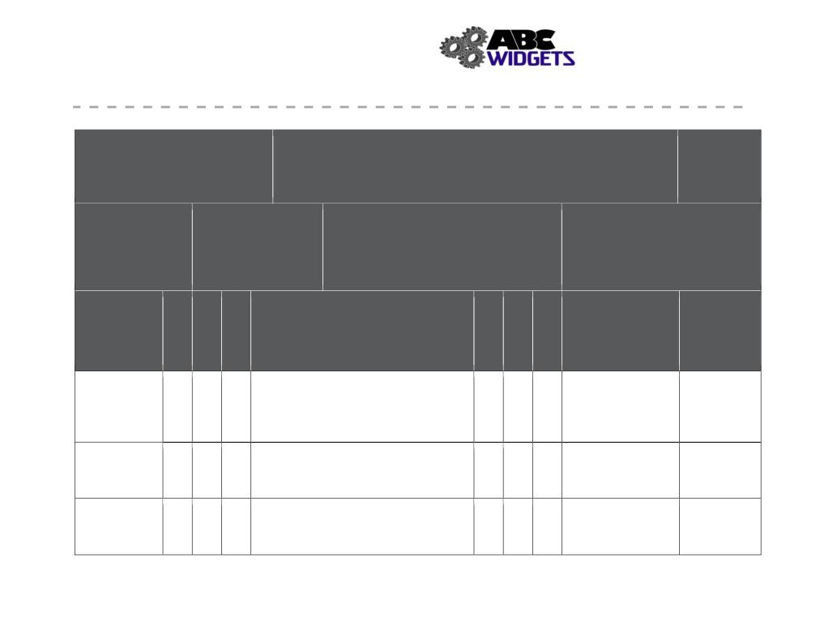

Health and Safety Manual
ABC Widget Oilfield Services Ltd. - FORMAL HAZARD ASSESSMENT

Task Assessed: Operate Table Saw
Positions Considered: Welders, machinist, Labourers

Assessment Team: (needs to include affected employee) FHA #: # 007
John Downy; Kris Marsh; Blake Edwards
Revision #: 1 Date: Nov. 1, 2018

Referenced
Legislation:
OH&S Code: Part 25- Tools Equipment
& Machinery

Hazards

Specialized PPE or
1.
Equipment:
2.
ear muffs, N-95 mask
3.
4.

Severity
Negligible/OK: Causing minor injury that requires first aid or
less
Minor: Causing non-serious injury, illness, or damage that re-
quires medical aid
Serious: Causing severe injury, serious illness, that is disabling or lifelong, or property and equipment damage
Imminent danger: Causing death, widespread occupational ill-
ness, or loss of facilities

Probability
1. Extremely Remote: Unlikely to occur
2. Remote: Could occur at some point
3. Reasonably Probable: Likely to occur eventually
4. Probable: Likely to occur immediately or soon

Outstanding Expected

Associated with Existing Hazard Controls Implementation Completion
Task Assigned To Date

Contact with Eng: guard, adequate lighting facility, fence
Blade Admin: push stick, Training, proper tool
3 4 12 3 3 9
selection,
PPE: gloves

Flying debris Eng: guard, vacuum dust suppresion
(eye hazard) 3 4 12 Admin: training 2 3 6
PPE: safety glasses

Awkward Eng: portable roller stands Look into possible Jan 2019,
lift/hold 3 4 12 Admin: SWP# 005, Training 2 3 6 extension for table Jon Downy
PPE:

125
Severity
Probability
Priority
Severity
Probability
Priority

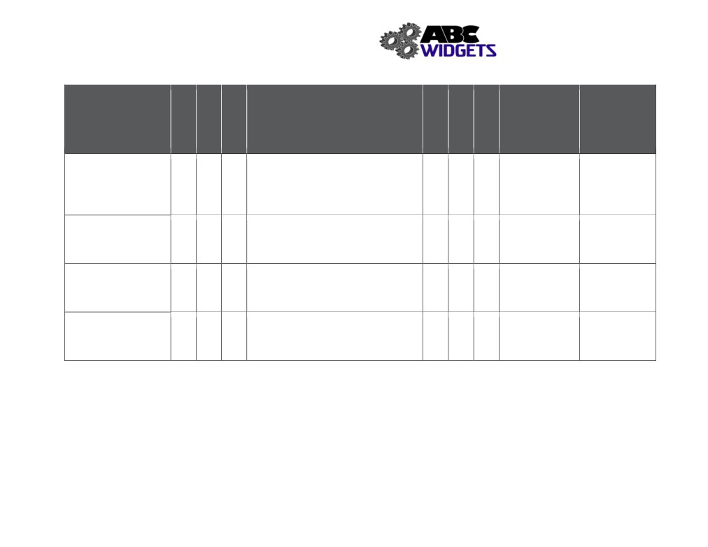

Health and Safety Manual

Hazards Associated with Task

Blade failure

4 4 16

Dust (inhalation)
2 4 8

Dust
(explosive atmosphere) 4 3 12

Noise
2 4 8

Existing Hazard Controls

Eng:
Admin: SJP # 006; pre-use inspection, PM
program, procurement Q/A
PPE:
Eng: vacuum dust suppression Admin: fit testing for masks
PPE: n-95 mask

Eng: vacuum dust suppression
Admin: SJP# 006, no smoking shop policy
PPE:

Eng:
Admin: work rotation
PPE: ear muffs

Outstanding Expected
Implementation Completion
Assigned To Date

4 3 12

2 3 6

Look into Jan 2019, mgmt.
4 2 8 automatic team
sprinkler system

2 3 6

126
Severity
Probability
Priority
Severity
Probability
Priority

