Health and Safety Manual
ABC Widget Oilfield Services Ltd. - FORMAL HAZARD ASSESSMENT
Task Assessed: Operate Chop Saw
Assessment Team: (needs to include affected employee)
FHA #: # 006
Revision #: 1
John Downy; Kris Marsh; Blake Edwards
Date: Nov. 1, 2018
Positions Considered: shop & field
supers, Welders, Machinists, Labourers
Referenced
Legislation:
OH&S Code: Part
25- Tools Equipment
& Machinery
Specialized PPE or
Equipment:
Face Shield; N-95
Mask,boots,gloves,ear
muffs
Severity
Probability
1. Negligible/OK: Causing minor injury that requires first aid or
less
2. Minor: Causing non-serious injury, illness, or damage that re-
quires medical aid
3. Serious: Causing severe injury, serious illness, that is disabling
or lifelong, or property and equipment damage
4. Imminent danger: Causing death, widespread occupational ill-
ness, or loss of facilities
1. Extremely Remote: Unlikely to occur
2. Remote: Could occur at some point
3. Reasonably Probable: Likely to occur eventu-
ally
4. Probable: Likely to occur immediately or soon
Hazards
Associated with
Task
Outstanding
Implementation
Assigned To
Expected
Completion
Date
Existing Hazard Controls
Contact with
Blade
Eng: guard, adequate lighting facility
Admin: SJP # 006; Training, proper tool selection,
PPE: boots, gloves
3
3
3
4
4
4
12
12
12
3
2
2
3
3
3
9
6
6
Flying debris
(eye hazard)
Eng: guard, vacuum dust suppresion
Admin: SJP # 006, training
PPE: safety glasses
Awkward
lift/hold
Eng: integrated bench and material rest, clamp
Admin: SJP # 006, Training
PPE:
123
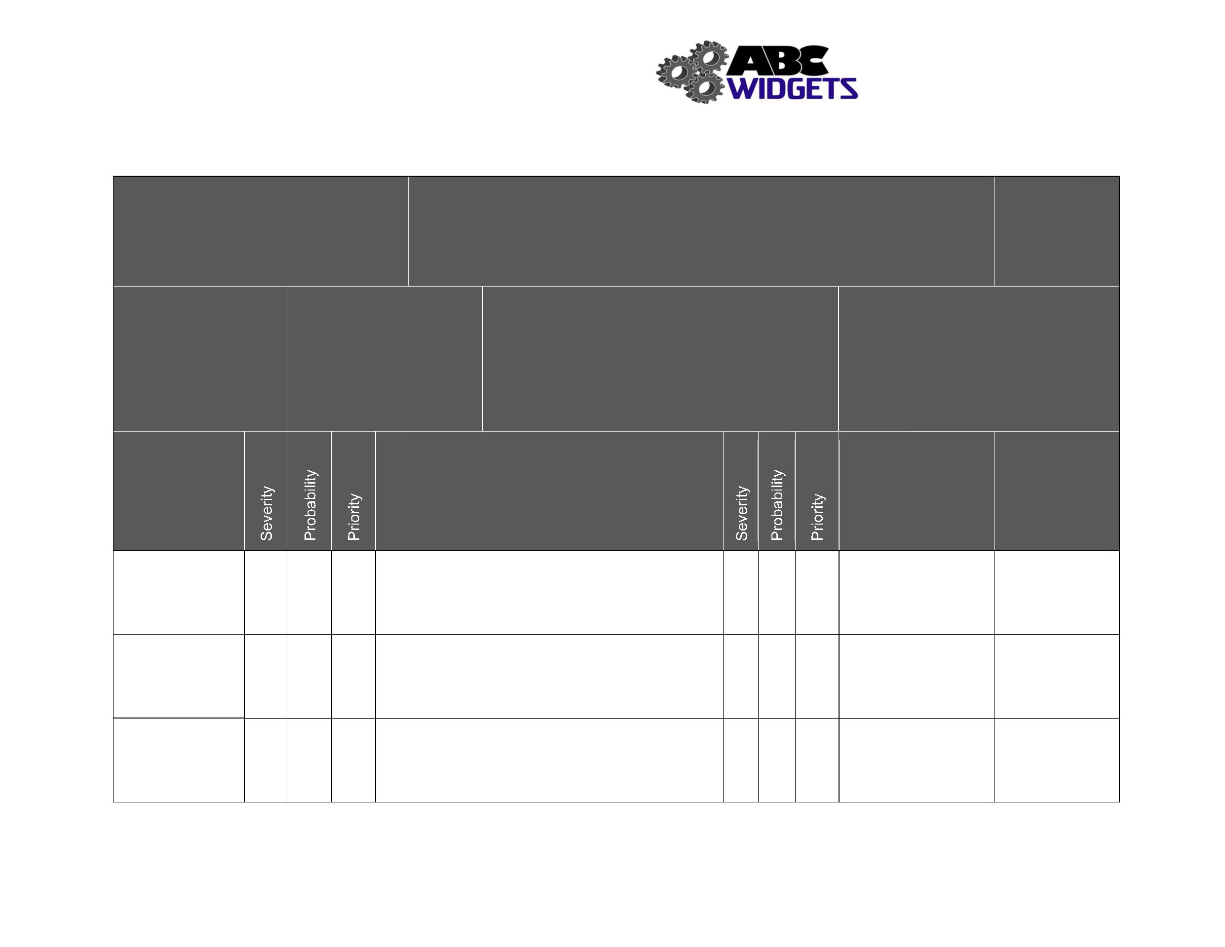

Health and Safety Manual
Outstanding
Implementation
Assigned To
Expected
Completion
Date
Hazards Associated
with Task
Existing Hazard Controls
Falling material (feet)
Eng: clamps
2
2
4
4
8
8
Admin: SJP # 006; Training
PPE: boots
2
2
3
3
6
6
Pinch Points
Blade failure
Eng: adequate shop lighting
Admin: SJP # 006
PPE:
Eng:
Admin: SJP # 006; pre-use inspection, PM
program, procurement Q/A
PPE:
4
2
4
4
16
8
4
2
3
3
12
6
Dust (inhalation)
Eng: vacuum dust suppression
Admin: fit testing for masks
PPE: n-95 mask
Dust
Eng: vacuum dust suppression
Admin: SJP# 006, no smoking shop policy
PPE:
Look into
automatic
sprinkler system
Jan 2019, mgmt.
team
(explosive atmosphere)
4
2
3
4
12
8
4
2
2
3
8
6
Noise
Eng:
Admin: work rotation
PPE: ear muffs
124
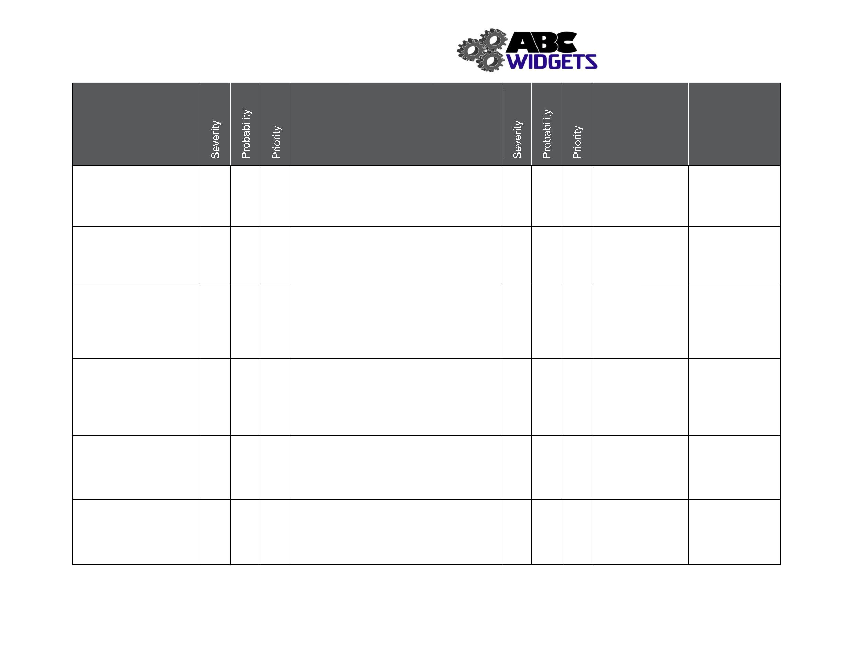

Only two pages were converted.
Please Sign Up to convert the full document.
www.freepdfconvert.com/membership
