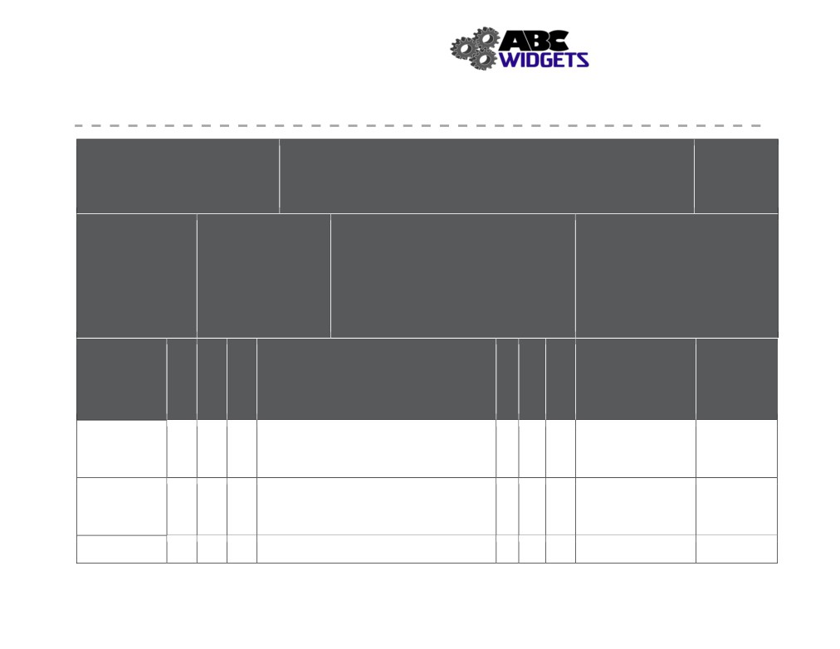

Health and Safety Manual
ABC Widget Oilfield Services Ltd. - FORMAL HAZARD ASSESSMENT

Task Assessed: Operate CNC Lathe

Positions Considered: Machinist

Assessment Team: (needs to include affected employee) FHA #: # 003
John Downy; Kris Marsh; Blake Edwards
Revision #: 1
Date: Nov. 1, 2018

Referenced
Legislation:
OH&S Code: Part 25- Tools Equipment
& Machinery

Hazards

Specialized PPE or
1.
Equipment: 2.
3.
neoprene gloves,Safety
4.
glasses,ankle-high boots,ear
plugs.faceshield

Severity
Negligible/OK: Causing minor injury that requires first aid or less
Minor: Causing non-serious injury, illness, or damage that re-
quires medical aid
Serious: Causing severe injury, serious illness, that is disabling or lifelong, or property and equipment damage
Imminent danger: Causing death, widespread occupational ill-
ness, or loss of facilities

Probability
1. Extremely Remote: Unlikely to occur
2. Remote: Could occur at some point
3. Reasonably Probable: Likely to occur eventually
4. Probable: Likely to occur immediately or soon

Outstanding Expected

Associated with Existing Hazard Controls Implementation Completion
Task Assigned To Date

Pinch Points Eng:
2 4 8 Admin: SJP # 003 2 3 6
PPE:

Obstructed Eng: adequate lighting
terrain 2 4 8 Admin: SWP # 001 2 3 6
PPE: ankle-high boots

Sharp edges 2 3 6 Eng: adequate lighting 1 2 2

115
Severity
Probability
Priority
Severity
Probability
Priority

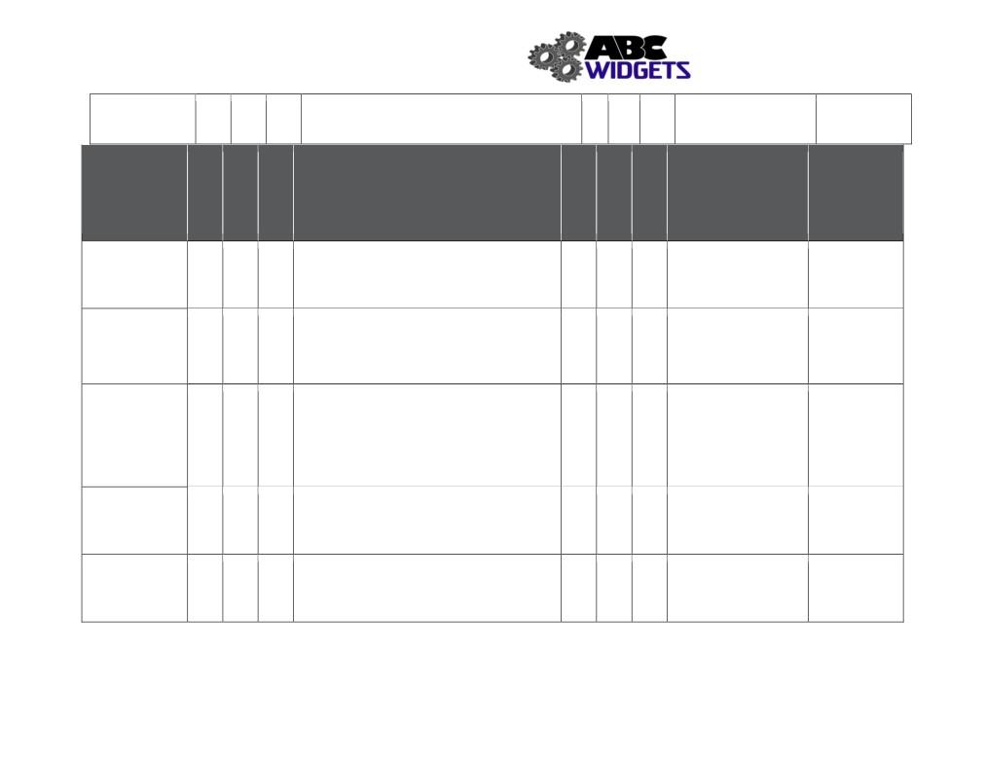

Health and Safety Manual
Admin:
PPE: neoprene gloves

Hazards Outstanding Expected
Associated with Existing Hazard Controls Implementation Completion
Task Assigned To Date

Drop Material Eng:
4 4 16 Admin: SWP # 005, SJP # 010 4 3 12
PPE: neoprene gloves

Awkward/heavy Eng: dolly, jib crane, overhead crane, forklift
lift 2 4 8 Admin: SWP # 005, SJP # 010 trained Worker 2 3 6
PPE: gloves

Entanglement Eng: interlocked access door, deadman foot
pedal
4 4 16 Admin: SJP# 003, LOTO procedures, competent 4 3 12
operator only
PPE:

Flying debris Eng: interlocked access door, viewing window
2 4 8 Admin: SJP# 003, 2 3 6
PPE: safety glasses

Material ejecting Eng: interlocked access door
from machine 4 4 16 Admin: SJP# 003 4 3 12
PPE: safety glasses

116
Severity
Probability
Priority
Severity
Probability
Priority

Health and Safety Manual

Hazards Associated with Task

Noise
2 4 8

Exposure to cutting fluid
(hazardous product)
2 4 2

Existing Hazard Controls

Eng: fully contained machining space Admin: work rotation
PPE: ear plugs

Eng: adequate lighting
Admin: Policy # 004, MSDS training, LOTO
procedure
PPE: neoprene gloves, safety glasses and face
shield

Outstanding Expected
Implementation Completion
Assigned To Date

2 3 6

2 3 6

117
Severity
Probability
Priority
Severity
Probability
Priority

